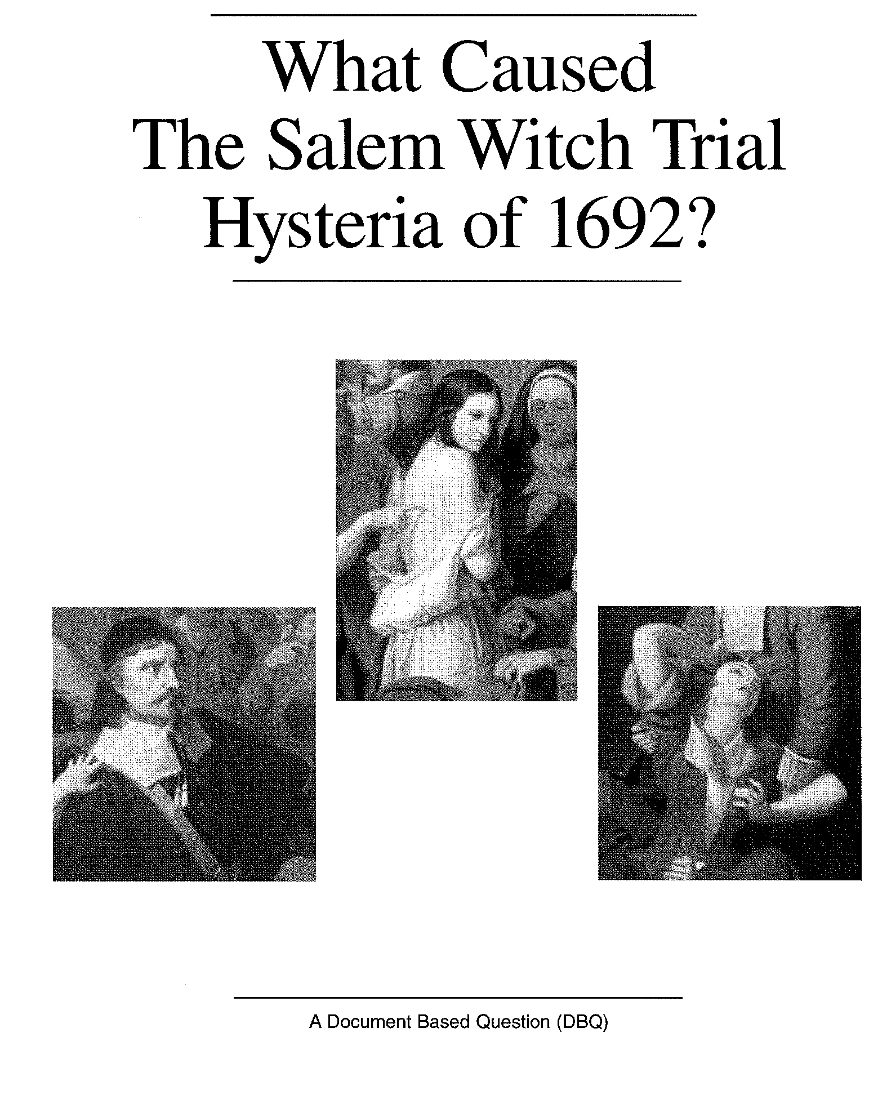

Directions & Questions

Directions: In the warm summer months of 1692, twenty women and men were put to death in Salem, Massachusetts, for practicing witchcraft. Why this happened has been the subject of historical debate for many years. Witchcraft hangings on this scale had never happened before in American and have never happened since. This document based exercise asks you for your educated opinion as to why they occurred.
Essentially what you will do is read the Background Essay and the Documents Packet on the Salem Witch Trials and then build a persuasive essay that answers the questions “What caused the Salem Witch Trial Hysteria of 1692?”

There are several steps to forming an educated opinion based essay:
- Read the Background Essay. It gives an overview of the Salem story.
- Quickly skim through the documents to get a sense of what they are about.
- Read the documents slowly. For EACH one record the following on your own paper:
  - What or who is the source?
  - Is it a primary or secondary source?
  - What is the main idea (or main ideas) in the document?
- Organize all of the documents into common themes or theories. All the documents relate to the Salem trials but some documents “link” together better than others to create a common idea or theory.
- After organizing all the documents, narrow your theories to one or two reasons for “What caused the Salem Witch Trial Hysteria of 1692?”
- Prioritize your reasons. What is the most important? What is second?
- Explain your priorities. Why is one reason more important than another?
- Back up your reasons/theories with evidence from the documents.

CONSIDER THIS INFO WHEN CONSTRUCTING YOUR ESSAY:
Length | - This essay should be roughly two to three pages double spaced, 12 point font, Times New Romans  - Have an introduction paragraph, body paragraphs, and a conclusion paragraph.
Introduction | - Introductions should be more than just a thesis  - To develop introductions:  - Utilize the background information to set the stage of the topic.  - Thesis should be evident
Body Paragraphs | - Each paragraph needs a topic sentence  - Evidence needs to be present. An ideal situation is at least 3 pieces of evidence.  - Use quotes from the documents (not the background essay)  - Summarize and/or paraphrase longer text or visual documents  - Links: Should do two things –  - Explain the evidence in your own words  - Explain how the evidence proves that your claim as related to the topic sentence and thesis of your essay  - A concluding sentence should help bring together your claim in each paragraph and serve as a transition to the next claim.
Quality of Arguments | - Answer the question being asked!!!  - Must explain how each piece (or group) of evidence PROVES your claim as related to the question.  - Example: How does a piece of evidence prove that religion was the cause of the hysteria?  - Example: How does document 5 help prove the theory that age/gender was the cause of the hysteria?
Grammar & Usage | - Self-edit: Read aloud your own writing. . . Are there any missing words? Are there areas where things aren’t so clear? . . . FIX!!  - There, Their, They’re . . . Make sure you are using these words appropriately

IN CONCLUSION you are going to:
(a) Complete the background essay questions
(b) Complete the document packet graphic organizers
(c) Write an essay that addresses your major theory/theories to: “What caused the Salem Witch Trial Hysteria of 1692?”
(d) Send questions, document packet, and essay through Engrade under a Turnin

BACKGROUND ESSAY QUESTIONS
- In what year did the Salem witch trials begin and end?

- How seriously did the Puritans take the written word of the Bible?

- What were some kinds of evidence used to determine if a person was a witch?

- According to Puritan belief, what is the connection between the Devil and a witch?

- What was one reason the hangings stopped after September 22?

- DEFINE
- Puritans

- predestination

- fundamentalists

- witch

DOCUMENT “A”
Name of Document:
Author of Document:
Date of Document: | Primary Secondary
What is the overall main idea of the document? (What is it about?)

What kinds of facts can I gain from this document? | What inferences can you make from this document?

DOCUMENT “B”
Name of Document:
Author of Document:
Date of Document: | Primary Secondary
What is the overall main idea of the document? (What is it about?)

What kinds of facts can I gain from this document? | What inferences can you make from this document?

DOCUMENT “C”
Name of Document:
Author of Document:
Date of Document: | Primary Secondary
What is the overall main idea of the document? (What is it about?)

What kinds of facts can I gain from this document? | What inferences can you make from this document?

DOCUMENT “D”
Name of Document:
Author of Document:
Date of Document: | Primary Secondary
What is the overall main idea of the document? (What is it about?)

What kinds of facts can I gain from this document? | What inferences can you make from this document?

DOCUMENT “E”
Name of Document:
Author of Document:
Date of Document: | Primary Secondary
What is the overall main idea of the document? (What is it about?)

What kinds of facts can I gain from this document? | What inferences can you make from this document?

DOCUMENT “F”
Name of Document:
Author of Document:
Date of Document: | Primary Secondary
What is the overall main idea of the document? (What is it about?)

What kinds of facts can I gain from this document? | What inferences can you make from this document?

DOCUMENT “G”
Name of Document:
Author of Document:
Date of Document: | Primary Secondary
What is the overall main idea of the document? (What is it about?)

What kinds of facts can I gain from this document? | What inferences can you make from this document?

DOCUMENT “H”
Name of Document:
Author of Document:
Date of Document: | Primary Secondary
What is the overall main idea of the document? (What is it about?)

What kinds of facts can I gain from this document? | What inferences can you make from this document?

DOCUMENT “I”
Name of Document:
Author of Document:
Date of Document: | Primary Secondary
What is the overall main idea of the document? (What is it about?)

What kinds of facts can I gain from this document? | What inferences can you make from this document?

DOCUMENT “J”
Name of Document:
Author of Document:
Date of Document: | Primary Secondary
What is the overall main idea of the document? (What is it about?)

What kinds of facts can I gain from this document? | What inferences can you make from this document?

DOCUMENT “K”
Name of Document:
Author of Document:
Date of Document: | Primary Secondary
What is the overall main idea of the document? (What is it about?)

What kinds of facts can I gain from this document? | What inferences can you make from this document?

DOCUMENT “L”
Name of Document:
Author of Document:
Date of Document: | Primary Secondary
What is the overall main idea of the document? (What is it about?)

What kinds of facts can I gain from this document? | What inferences can you make from this document?

DOCUMENT “M”
Name of Document:
Author of Document:
Date of Document: | Primary Secondary
What is the overall main idea of the document? (What is it about?)

What kinds of facts can I gain from this document? | What inferences can you make from this document?

