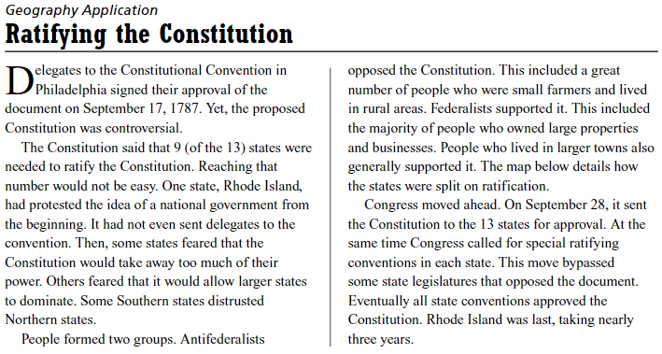
35pts

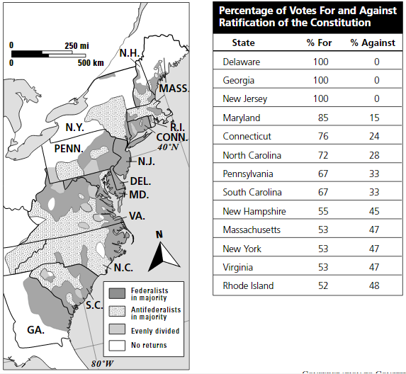

**Write in complete sentences & write answers in RED!!**

- Which three states supported only the Federalist pro-ratification position?

- Georgia was 100 percent in favor of ratifying the Constitution. Yet unlike New Jersey and Delaware, the state is not completely covered by “Federalists in majority” patterning. Explain how this could be.

- Which position won more support in coastal areas (where the biggest towns are located)?

- Where was Antifederalist support concentrated mainly?

- Look at the pattern for New York. Antifederalists controlled most of the state’s territory. Why do you support that support for ratification won out?

- Why is it not surprising that Rhode Island’s vote total was the closest?

- Consider the map again. What would have happened if New York alone had failed to vote for ratification?

