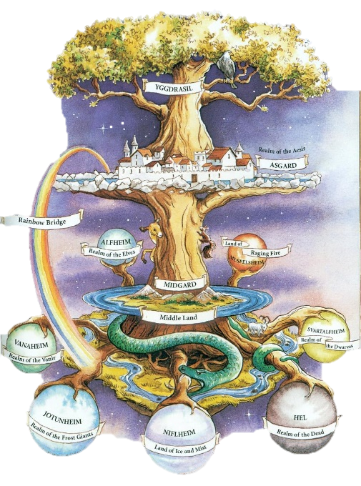
NORSE
MYTHOLOGY
WEBQUEST

70pts

INFO ABOUT NORSEMEN & VIKINGS
Go to http://mythologyteacher.com/documents/Norsegods.pdf to answer
the questions about Norse Mythology
- What countries do the “Norse” encompass?

- Who were Norsemen?

- Who were Vikings?

- Were women equal to men in the Norse society?

- Who were the 1st to discover North America?

CREATION MYTH
- Go to http://www.pitt.edu/~dash/creation.html or https://www.theodysseyonline.com/the-norse-creation-myth and http://norse-mythology.org/tales/norse-creation-myth/ in order to answer the following questions:
- Describe Muspell
- Who is Ymir?
- Who is Audhumla?
- Who is Odin and who is Odin’s parents & brothers?
- What happened to Ymir?
- Who was Ask and Embla?

WORLDS & REALMS
- Go to http://norse-mythology.org/ and click on the tab “COSMOLOGY” to be able to explain each world:
- Asgard –

- Jotunheim –

- Svartheim –

- Midgard –

- Niflheim

- Go to http://norse-mythology.org/ and click on the tab “COSMOLOGY” to be able to explain each:
- What is Yggdrasil ?
- What is Valhalla?
- What is Ginnungagap?
- What is Folkvang?

GODS & GODDESSES
- Go to http://norse-mythology.org/ and click on the tab “GODS AND CREATURES” to be able find and explain the following deities/creatures in Norse mythology. Be able to give at least three major facts about them and their significance:
- Odin

- Frigga

- Blader

- Thor

- Tyr

- Heimdall

- Freya

- Loki

- Valkyries

- Norns

- Giants

- Dwarves

- Ragnarok

