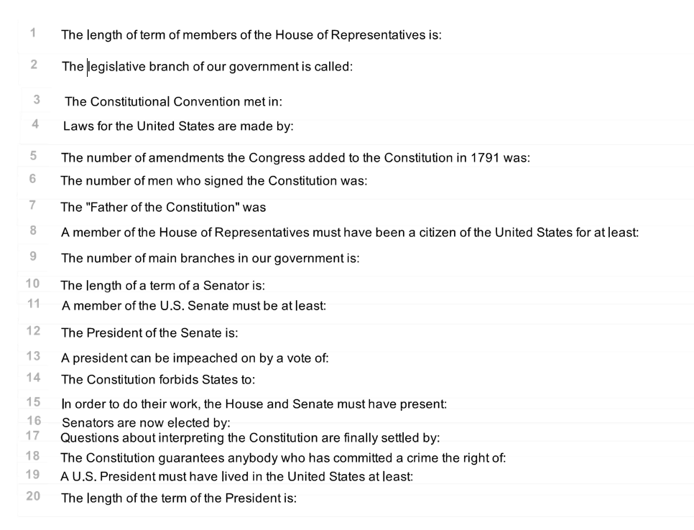
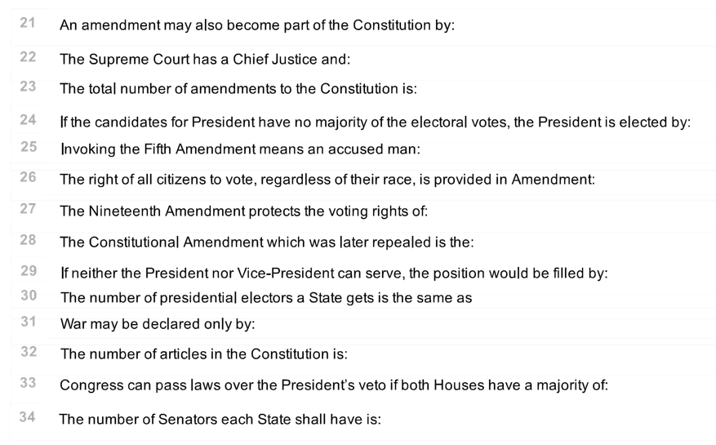

The number of electoral votes needed to become president of the U.S. is
Which of the following is NOT an expressed/enumerated power of the Congress?
In what year did the Constitution become the law of the land?
Which of the following is not protected by the First Amendment?
If each house of Congress has passed a different version of the same bill, where must the bill go next?
Which amendment protects you against an unreasonable search and seizure?

